Dashboard

The dashboard was built using micro strategy (<https://www.microstrategy.com/us>). Micro strategy enables the visualization of data by importing datasets. In this case the datasets from the results directory were used. The individual queries were run and then saved as CSV files which were then imported into the dashboard.

Micro strategy enables multiple methods of visualizations for your data (as seen in figure 1)

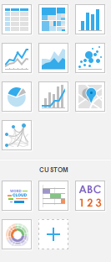

*Figure 1: Data display options*

Using the available options the dashboard is able to visualize queries 1-8 in a simplistic to understand manner. Microstrategy also enables the user to drilldown and rollup the data via the break by command. In figure 2 we have drilled down to the individual months; however, we could have also broken it down by year (or rollup the data by year).

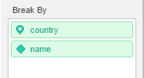

*Figure 2: The ability to drilldown and roll up by specific data*

There is also the option to create your own custom attributes based on filtering existing attributes. This enables father drill down to compare specific products, dates or really whatever the user needs to compare.

One drawback to our solution is that the dashboard is using static CSV files. However